**Department of Engineering Technology**



**Foundation University Islamabad** **School of Science and Technology**

**DSA Lab**

**Name: Muhammad Usman**

**Roll no: 079**

**Lab#: 01**

**Topic: _______ OBJECTIVES:**

i. Objective - 1 ii. Objective - 2

|  |  |  |  |  |  |
| --- | --- | --- | --- | --- | --- |
| **Performance** | |  | **Lab Report** | |  |
| **Description** | **Total**  **Marks** | **Marks Obtained** | **Description** | **Total**  **Marks** | **Marks** **Obtained** |
| Implementation of Code | 5 |  | Lab Exercises | 5 |  |
| **Total Marks obtained** | |  |  | |  |

**Q1:**

#include <iostream>

using namespace std;

int main() {

int marks[10] = {65, 78, 82, 90, 56, 88, 74, 93, 70, 85};

int max1 = -1, max2 = -1;

for (int i = 0; i < 10; i++) {

if (marks[i] > max1) {

max2 = max1;

max1 = marks[i];

} else if (marks[i] > max2 && marks[i] != max1) {

max2 = marks[i];

}

}

cout << "Highest mark: " << max1 << endl;

cout << "Second highest mark: " << max2 << endl;

return 0;

}

**Output:**

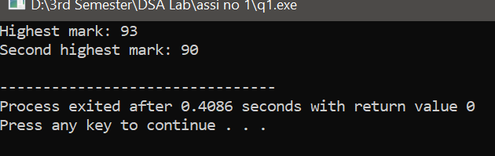

**Q2:**

#include <iostream>

#include <algorithm>

using namespace std;

int main() {

int size, target;

cout << "Enter the size of the array: ";

cin >> size;

int arr[size];

cout << "Enter " << size << " elements:\n";

for (int i = 0; i < size; i++) {

cout << "Element " << i + 1 << ": ";

cin >> arr[i];

}

sort(arr, arr + size);

cout << "Enter element to search: ";

cin >> target;

int low = 0, high = size - 1;

bool found = false;

while (low <= high) {

int mid = (low + high) / 2;

if (arr[mid] == target) {

found = true;

break;

} else if (arr[mid] < target) {

low = mid + 1;

} else {

high = mid - 1;

}

}

if (found) {

cout << "Element " << target << " found in the array.\n";

} else {

cout << "Element " << target << " not found in the array.\n";

}

return 0;

}

**Output:**

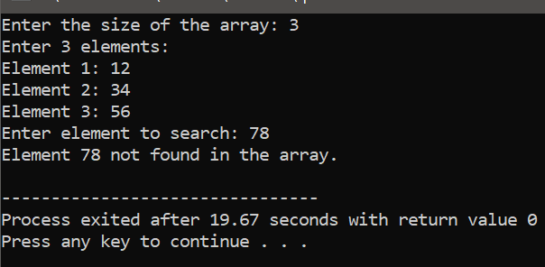

**Q3:**

#include <iostream>

using namespace std;

int main() {

const int SUBJECTS = 6;

int marks[SUBJECTS];

int sum = 0;

float average;

cout << "Enter marks of 6 subjects:\n";

for (int i = 0; i < SUBJECTS; i++) {

cout << "Subject " << i + 1 << ": ";

cin >> marks[i];

sum += marks[i];

}

average = sum / (float)SUBJECTS;

cout << "\nAverage Marks: " << average << endl;

if (average > 90) {

cout << "Grade: A+" << endl;

} else if (average > 80) {

cout << "Grade: A" << endl;

} else if (average > 70) {

cout << "Grade: B" << endl;

} else if (average > 60) {

cout << "Grade: C" << endl;

} else if (average > 50) {

cout << "Grade: D" << endl;

} else {

cout << "Grade: F" << endl;

}

return 0;

}

Output:

